# A000-Am,S-Colombia-Tairona-Tumbaga- Funerary Urn-1000-1500 CE

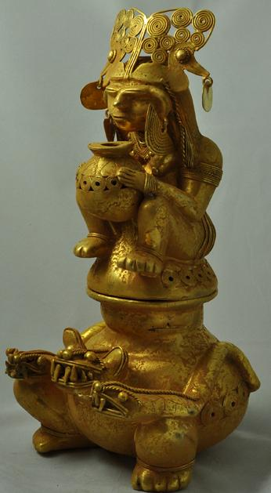

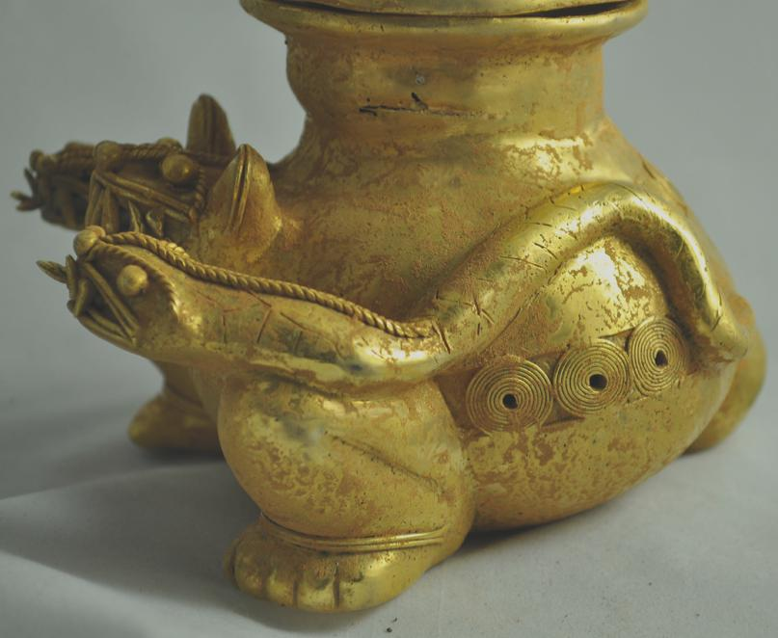 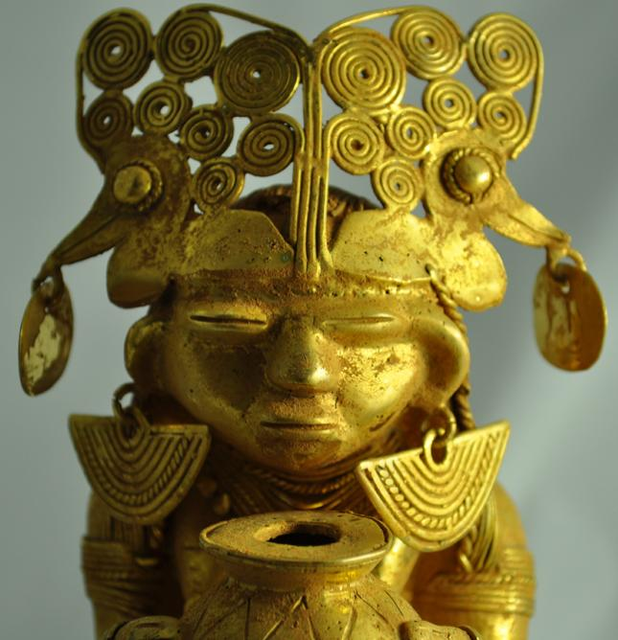 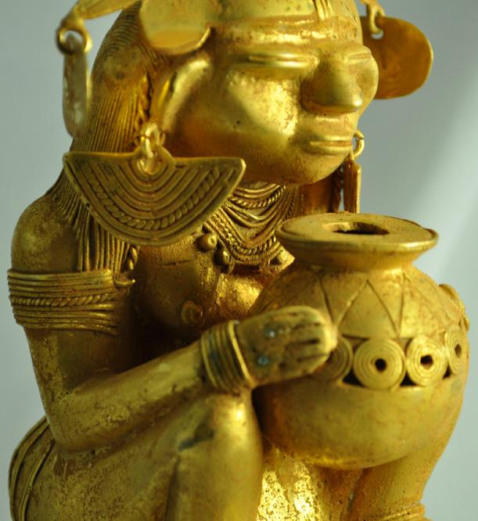 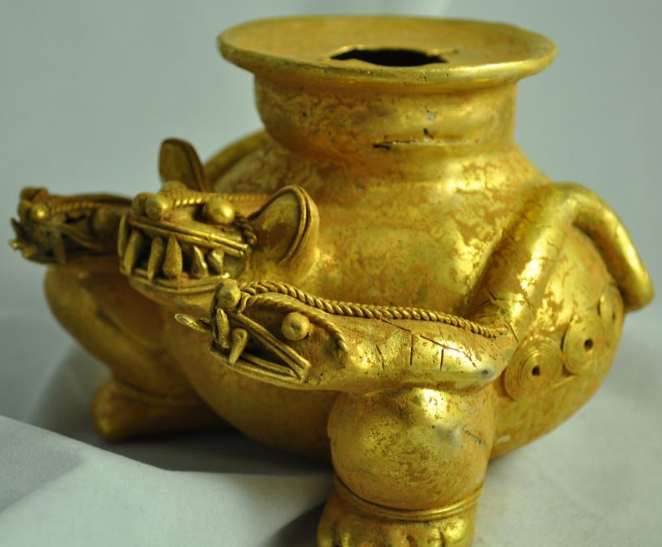 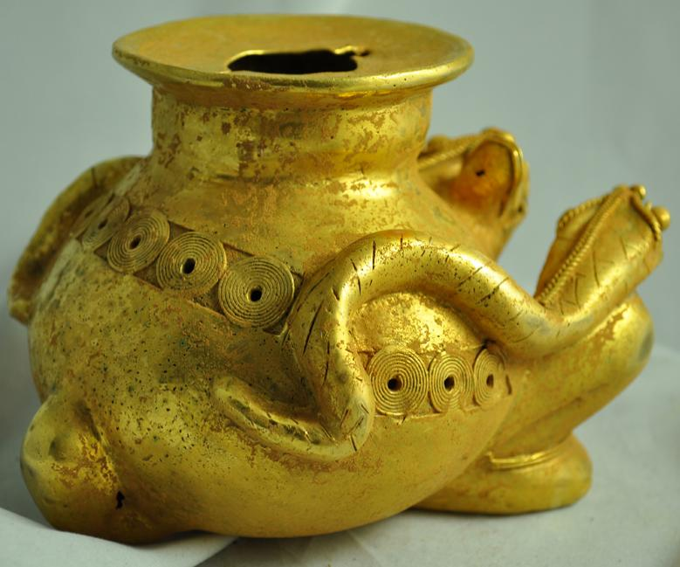 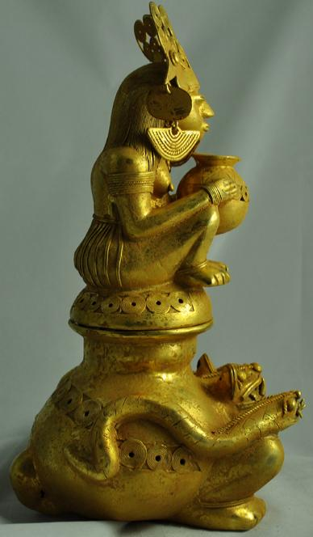 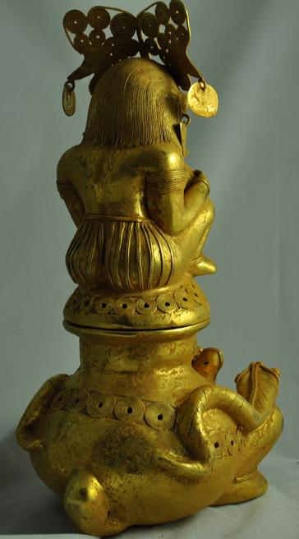 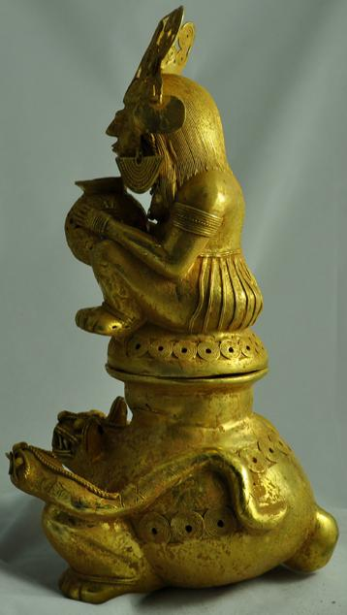

Figs. 1-9. **Colombia-Tairona-Tumbaga- Funerary Urn-1000-1500 CE**

 Weight of object is 1170 gm.

Size is. Clean patina and texture. Excellent antique condition.

Case No.: 7

**Accession No.**

**Formal Label:**

**Display Description:**

Extremely rare and massive size and weight object made by the lost wax technique in tumbaga. Finding from the north of Columbia.   
Object is the anthropomorphic representation of  a funerary urn. Urn was used for depositing human cremation remains. Urn can be closed or opened. Astonishingly fine, detailed figure.

**LC Classification:** 1170 gm.

**Date or Time Horizon: 1000-1500 CE**

**Geographical Area:**

**Map:**

**GPS coordinates:**

**Cultural Affiliation:**

**Media:**

**Dimensions:** 265 tall  x 112 wide mm

**Weight:**

**Condition:**

**Provenance:**

**Discussion:**

**References:**